# Senegalese Protest Music and American Hip Hop Activism

**Overview** This unit explores the similarities and differences of hip-hop activism in Senegal and the United States. Senegalese and African-Americans have used hip hop to introduce change, to promote human rights, and to protest against socio-political systems limiting full citizenship rights to certain people in their countries.

Hip hop music is rooted in every aspect of Senegalese and African-American culture. It is a musical movement started by the younger generations to express their cultural identity, and frustration about the social ills. This unit explores the influence of Hip Hop and Senegalese Protest music on cultural traditions, social norms, and political movements. While the groups may have different experiences with social injustice, they both work to fight for human rights using this music to inspire change and action within their communities.

# Essential Questions

Why do people make music?

How does music influence culture? How does culture influence music? Whose point of view comes forth in music?

How does studying other cultures help us understand our own?

**Senegalese Protest Music**- rappers with conscious lyrics addressing history, resistance against state institutions, and push for Pan-African solidarity. *Artists in West Africa are often referred to as modern day griots.*

**African American Political Hip-Hop Artists-** conscious rappers who write and perform songs that strike against injustices, provide a voice for the marginalized, and inspire social engagement among their audience to promote change.

**Hip-hop activism** combines progressive youth politics, community organizing, and hip-hop culture to address such issues as the prison industrial complex, emerging democracy and globalization, and education.

**Senegal-** a country in Africa.

**Griot-** a West African storyteller, poet, singer, musician, historian, and keeper of the oral tradition.

**Historical figure**- a person from the past who has made a significant and lasting impact on society both during his/her time and/or in the present.

**Key Concepts and Vocabulary**

# Materials

1. [Google Slides](https://docs.google.com/presentation/d/1EIfMcIN1pKusM8bm3mDWXIkH4UY1HHEe6NS-fzQtFQ8/edit?usp=sharing) to display during the lesson.
2. Poster paper or large whiteboard, dry-erase markers
3. Anchor chart paper, prepped with a Venn Diagram labeled Senegalese Protest Music on one side and the other side labeled American Hip Hop (example below)
4. Post-it notes or index cards to use as exit tickets
5. Optional: individual copies of the venn diagram for each student to fill out

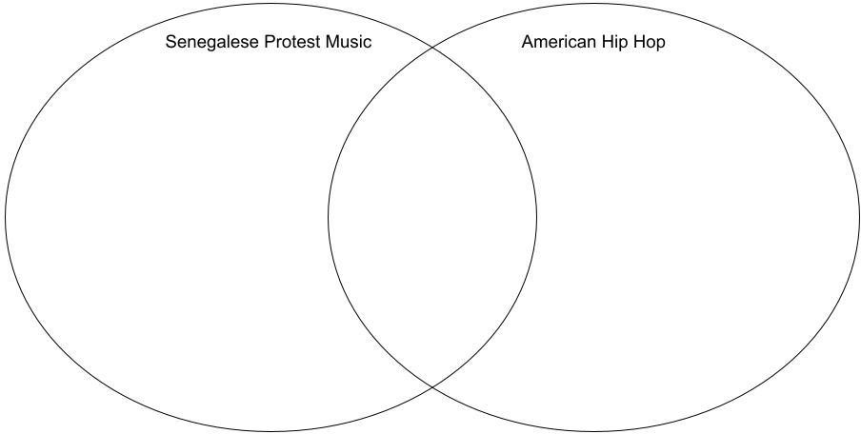

**note: you might also choose to display this Venn Diagram virtually**

# Preparation

This lesson will utilize an activity called [Concentric Circles](https://youtu.be/8x5NlIeySp4) to allow for discussion between multiple students (see link for detailed example). To set up for Concentric Circles, set up classroom chairs in 2 concentric circles facing each other. Alternatively, you may choose to do this activity with students standing up (this is particularly helpful if your classroom does not have space to set up chairs). In this case, you may consider putting tape marks on the floor as markers for students to stand on.

In the activity, each student seated/standing in the inside circle is paired with a student seated/standing in the outside circle. The teacher poses a question to the whole group and pairs discuss their responses with each other. Then the teacher signals students to rotate: Students on the outside circle move one space to the right so they are sitting in front of a new person. Now the teacher poses a new question, and the process is repeated

# Lesson 1: From Griots to American Hip Hop

**Procedures**

* Introduce the lesson by revisiting previous lessons on griots and storytelling in Senegal. Remind students that griots are musical storytellers.
* Tell students that today you will be learning about what many people consider to be modern-day griots.
* Instruct students to sit (or stand) in the Concentric Circle setup.
* Concentric Circle activity-- ask each question and allow 2-3 minutes for students to share ideas with their partners before rotating and asking the next question
  + Question 1: What do you remember about griots?
  + Question 2: What messages did griots convey in their music?
* While students are still in their circles, play the “Carry on Tradition” video (slide 2)
* After the video, return to the Concentric Circles setup, with the outside circle moving to the right. Ask the questions and allow 2-3 minutes for students to share ideas with their partners before rotating
  + Question 3: What similarities do you see in griot music and that of modern hip hop/rap?
  + Question 4: Do you listen to rap or hip hop music? Which rappers do you listen to?
  + Question 5: What messages to modern hip hop artists convey in their music?
* Ask students to return to their desks
* Allow 4-5 minutes for students to share their ideas from the Concentric Circles activity with the large group.
* Display the Venn diagram and explain that Venn diagrams help organize our thoughts to compare and contrast different things (slide 3)
  + Model filling in the diagram with ideas about hip hop by writing “rose from griots” in the right circle
  + “You all have noticed a lot of similarities between griots and modern hip hop. Now we’re going to think about how American hip hop is similar and different from the rap music in Senegal, where griots first created music.”
* Play the video on slide 4 on the Birth of Hip Hop.
* Allow students to add ideas about American hip hop to the right circle.
  + Venn diagram options:
    - Give each student a copy of the venn diagram for them to fill out
    - Fill out the anchor chart/digital version as a group-- allow students to write ideas directly on the chart or with post-it notes
    - Teacher calls on students and fills out chart for group
* “One thing we notice is that the message of many rap and hip hop songs was one of protest.”
* Ask students if they can think of any examples of protest hip hop songs or artists (you may choose to play snippets of these or other songs they mention-- the ones listed below are *clean* versions)
  + [Childish Gambino - “This is America”](https://www.youtube.com/watch?v=AftU8kNaorU)
  + [Public Enemy - “Fight the Power”](https://www.youtube.com/watch?v=5UAnW-c57gM)
  + [J. Cole - “Be Free”](https://www.youtube.com/watch?v=QXEvsUYfXoI)
  + [H.E.R. - “I Can’t Breathe”](https://www.youtube.com/watch?v=IRZWiqBHYaY)
  + [Kendrick Lamar - “Alright”](https://www.youtube.com/watch?v=6QbLcwVAsl0)
  + [Beyonce - “Formation”](https://www.youtube.com/watch?v=hF8YIKzNAOU)
* Save venn diagrams for use in the next lesson

# Lesson 2: Rap and Hip Hop as Protest in Senegal

**Procedures**

* Begin the lesson in the Concentric Circles setup you used in the previous lesson.
* Concentric Circle activity-- ask each question and allow 2-3 minutes for students to share ideas with their partners before rotating and asking the next question
  + Question 1: What do you remember about the beginning of hip hop in America?
  + Question 2: What messages do hip hop artists convey in their music?
* “Hip hop is not only an American art, however. After growing from the tradition of griots in West Africa, it returned to the continent by the 1990s.”
* Play the video on slide 6
  + Daara J is a famous and beloved Senegalese rap group
  + The song is sung in Wolof and the lyrics tell the story of how rap/hip hop returned to Senegal
* Concentric Circle activity-- ask each question and allow 2-3 minutes for students to share ideas with their partners
  + Question 1: What do you notice about the Senegalese song? How is it similar to American hip hop? How is it different?
* Tell students that, like American rappers, Senegalese rappers often rap about political and social issues.
  + “In fact, hip hop artists have been instrumental in the political elections in Senegal over the past 10 years.”
* Ask students to return to their seats.
* Return to the venn diagram you created in the previous lesson (either display your group diagram or have students return to their individual papers)
* Show the video on slide 8

**note: this video is subtitled and may not be easily accessed by all learners. Teachers might choose to read the subtitles aloud or skip this video altogether. Please choose what works best for your context**

* Show the video on slide 9

**note: the video is timed to stop after 3 minutes, however, older students (especially those learning about government systems in social studies lessons) may benefit from watching the entire video. Please choose what works best for your context**

* Allow time to fill out the left side of the venn diagram on Senegalese protest rap. You may allow students to do this individually, in partners, or as a large group with the anchor chart/displayed diagram.
  + As students work to fill out the chart, you may choose to play some of the Senegalese protest music on slide 10
* Once students have filled out the left side of the chart, talk as a group about the similarities between American hip hop and Senegalese protest music. Model for students how to write those similarities in the middle section of the venn diagram.
* EXIT TICKET: On a post-it note or index card, have students write one similarity and one difference between American and Senegalese hip hop

# Optional Extension: Make a Mix Tape!

Using the included worksheet, students will make their own hip hop mix tape.

* Allow students to select one Senegalese artist and one Hip-Hop artist to research using these sources:

1. [Trans-Atlantic Memories: Senegal’s Hip-Hop Griots and the Black Radical](https://www.caorc.org/post/trans-atlantic-memories-senegal-s-hip-hop-griots-and-the-black-radical-tradition#%3A~%3Atext%3DA%20griot%20is%20a%20West%2Cthe%20keeper%20of%20oral%20tradition) [Tradition](https://www.caorc.org/post/trans-atlantic-memories-senegal-s-hip-hop-griots-and-the-black-radical-tradition#%3A~%3Atext%3DA%20griot%20is%20a%20West%2Cthe%20keeper%20of%20oral%20tradition)
2. [Hip-hop has been standing up for Black lives for decades: 15 songs and](https://abcnews.go.com/Entertainment/hip-hop-standing-black-lives-decades-15-songs/story?id=71195591) [why they matter](https://abcnews.go.com/Entertainment/hip-hop-standing-black-lives-decades-15-songs/story?id=71195591)

* Ask students to fill out the mixtape worksheet, labeling and coloring in their mixtape.
* Once students have completed their mixtape, they may share with the class.